

**INSTALLATION MANUAL**

### **Table of Contents**

### **Applicable Version………………..…....……………………………….…………………….2**

### **Configuring Ingenico………………..…………………………………………………………2**

### **Feature List ……….....………………..…………………………………………………………4**

### **Plugin Installation ...………………..…………………………………………………………8**

### 

### **Applicable versions**

|  |  |
| --- | --- |
| **Applications** | **Versions** |
| .NET Core | 2.1 |
| MVC | 5.2.4 |
| nopCommerce | 4.20 |

### **Configuring Ingenico**

1. Go-to http://<your-hostname>/admin/Ingenico/Configure
2. Scroll down. You will see ingenico, Edit it
3. Configure it as below:

|  |  |
| --- | --- |
| **Column Name** | **Description** |
| Status | “Enable” to enable and use, else “Disable” to disable ingenico |
| Merchant Code | Enter Merchant Code |
| Salt | Enter Salt. |
| Payment Type | For Test mode Select ‘Test’ and for Live mode select ‘Live’ |
| Merchant Scheme Code | Enter Scheme Code |

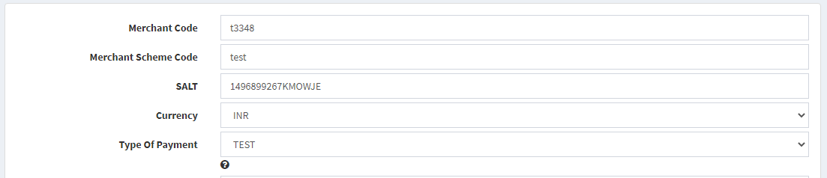

1. Now click on “Submit” at the bottom of the page
2. Ingenico Payment Gateway is now configured & ready to use.

### **Advanced Configuration**

There are also some advanced configuration options you may consider as shown below:

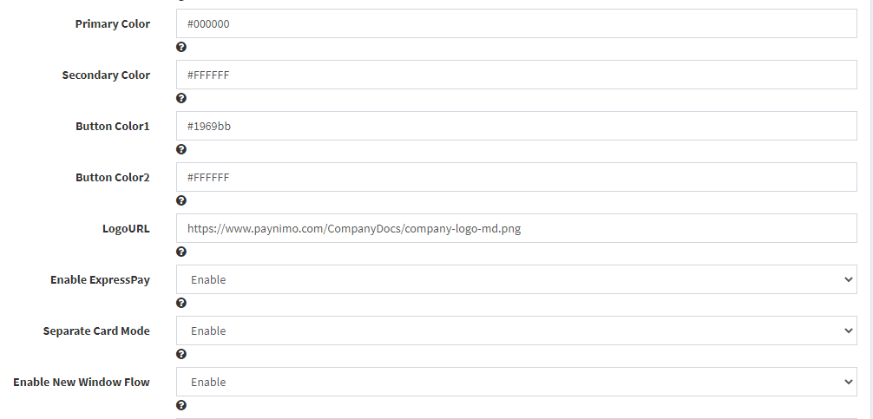

## 

## **Features List**

### **Online Transaction**

To make an online transaction go to add aprouct to cart, then go to cart

http://<your-hostname>/cart and click on Checkout

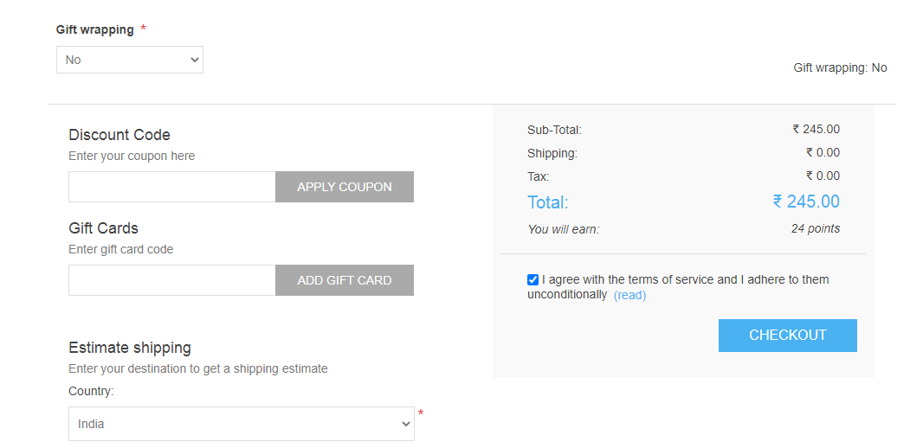

It will take you to the checkout page, select Shipping address, Shipping method then payment method as Ingenico, it will lead you to the Payment Info section. Click on Pay button to make payment.

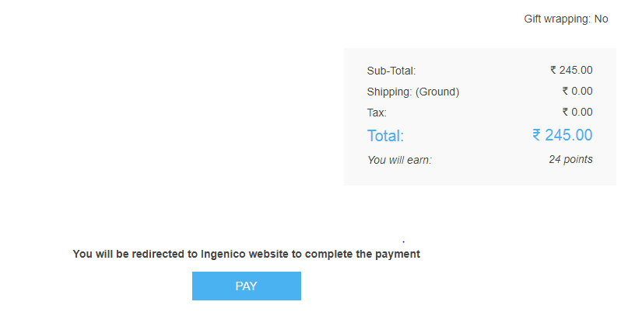

### **Reconciliation**

Merchants can update the pending status of the order automatically if the payments are successful. This page can be found at http://<your-hostname>/admin/Ingenico/reconcile

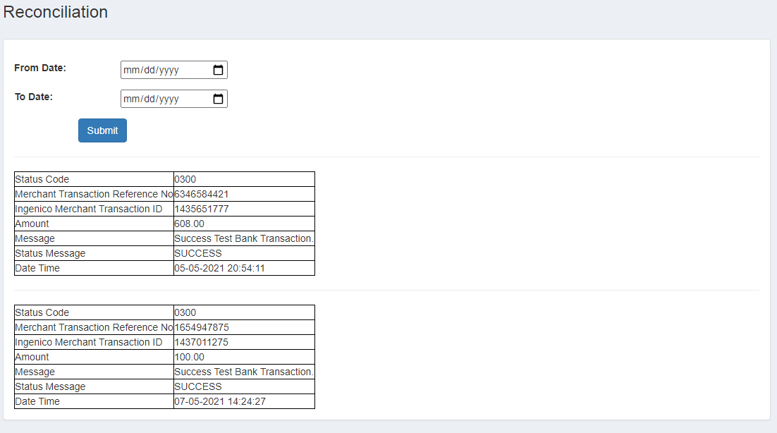

### **S2S Verification**

If we do not receive any response from the payment gateway then after 30 mins, we will get a response from the server and based on the response it will update order status.

To configure S2S URL, contact prod team.

S2S url format : http://<your-hostname>/Ingenico/s2s?msg=

Example:

http://<your-hostname>/Ingenico/s2s?msg=0300|success|NA|5236549778|470|1432994096|530.00|NA|02-05-2021%2019:18:25|NA||TEST%20BANK|1111432994096||6ffb0b36-2316-40b8-821a-69b8c842c7cc|5d2f7c17f70e6e9b6e709c9eba1032b849970a0aff259646b7b1a9e3d4a9e3b40270720307f60ec2092c58f358ec1141a42ffc9912ec4f1ab6342c998a3d6c13

### **MCG**

It supports the multi-currency like INR & USD and a lot more can be added.

### **Offline Verification**

Merchants can verify the status of their payment by using the Payment Verification page. The payment verification page can be found at

http://<your-hostname>/admin/Ingenico/offline-verification

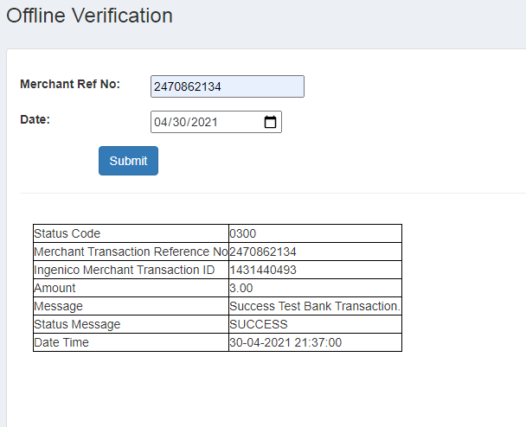

### **Refund**

Merchants should be able to process the refund online for the order whose payment has been done via Ingenico.

To refund an order go to http://<your-hostname>/admin/Ingenico/refund

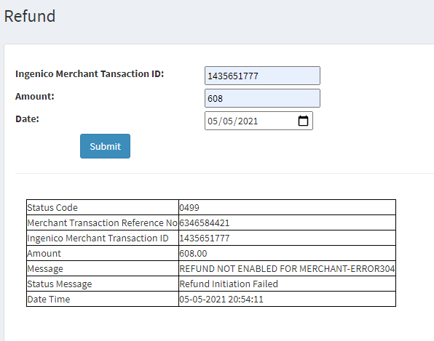

## 

### **Plugin Installation**

### **To install a plugin**

1. The user has two options for uploading the plugin. You can use any that seems most convenient:

* Upload the plugin to the /plugins folder in your nopCommerce directory. And restart your application (or click Reload list of plugins button).
* Upload the plugin or theme using the Upload plugin or theme button indicating the path to the location of the archive with the plugin in your local storage.

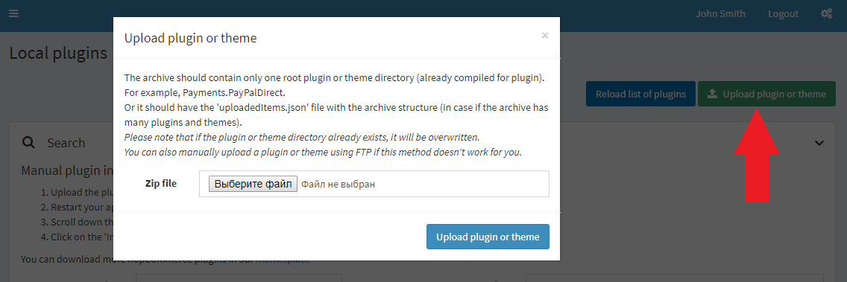

1. Scroll down through the list of plugins to find the newly installed plugin.
2. Click on the Install link to install the plugin.
3. Click on the Restart application to apply changes button on the top panel to finish the installation process.
4. The plugin is displayed in the plugins list (**Configuration → Local plugins**).

## **To configure a plugin**

1. Go to **Configuration → Local plugins**. The plugins list is displayed:

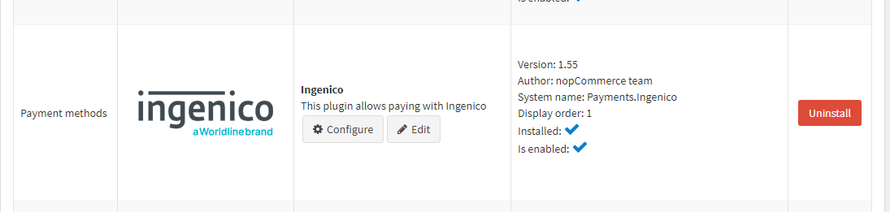

1. Click the **Configure** link beside the plugin to go to the plugin's configuration page.

## **To uninstall a plugin**

## Click the Uninstall link beside the plugin to uninstall. The plugin is uninstalled. The link in the Installation column changes to Install enabling you to reinstall the plugin at any time.

1. Click on the Restart application to apply changes button on the top panel to finish the uninstallation process.

## **Documentation link**

[**https://www.tecprocesssolution.com/proto/p2m/client/salt-based-documentation.htm#online**](https://www.tecprocesssolution.com/proto/p2m/client/salt-based-documentation.htm#online)